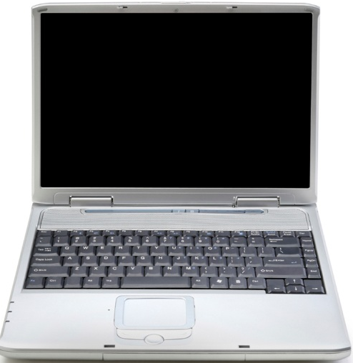

NO BYOT

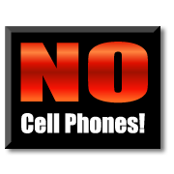

Please put your personal technology devices away. It is time for other work.

RULES of BYOT
Bring Your Own Technology Classroom Rules!

- Take Care of you own device.
  - Do not lose it, abuse it or let others misuse it.
  - Keep an eye on it – so it doesn’t disappear.
  - Handle with care – a broken device doesn’t help anyone
- Listen to your teacher – Teachers make the final decision
for any tools used in the classroom
- Access only school related resources.
- Internet access is still filtered and tracked.
Be responsible in your use of school resources.
- No texting, e-mailing, face-booking, twittering, blogging or other social contacts outside the classroom.
- Leave your device on the desk in front of you.
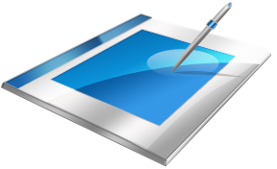
- If sharing someone else’s device – please be considerate and careful.

www1.aasd.k12.wi.us

