Task Card

Learning Target- Explain what is matter. Describe the properties of an object in the classroom.

Activity:

* Read Lesson 1 with your group.
* Discuss and give examples of matter.
* Choose 3 examples of matter in the classroom and describe 3 different properties of that matter.
* Choose one of the ways below to share your work with your smart device.
  + Draw a picture of your matter and its properties.
  + Write about the matter you chose and list its properties.
  + Take a picture of your matter and tell about its properties.
  + Video-record your group discussing the matter and describing its properties.

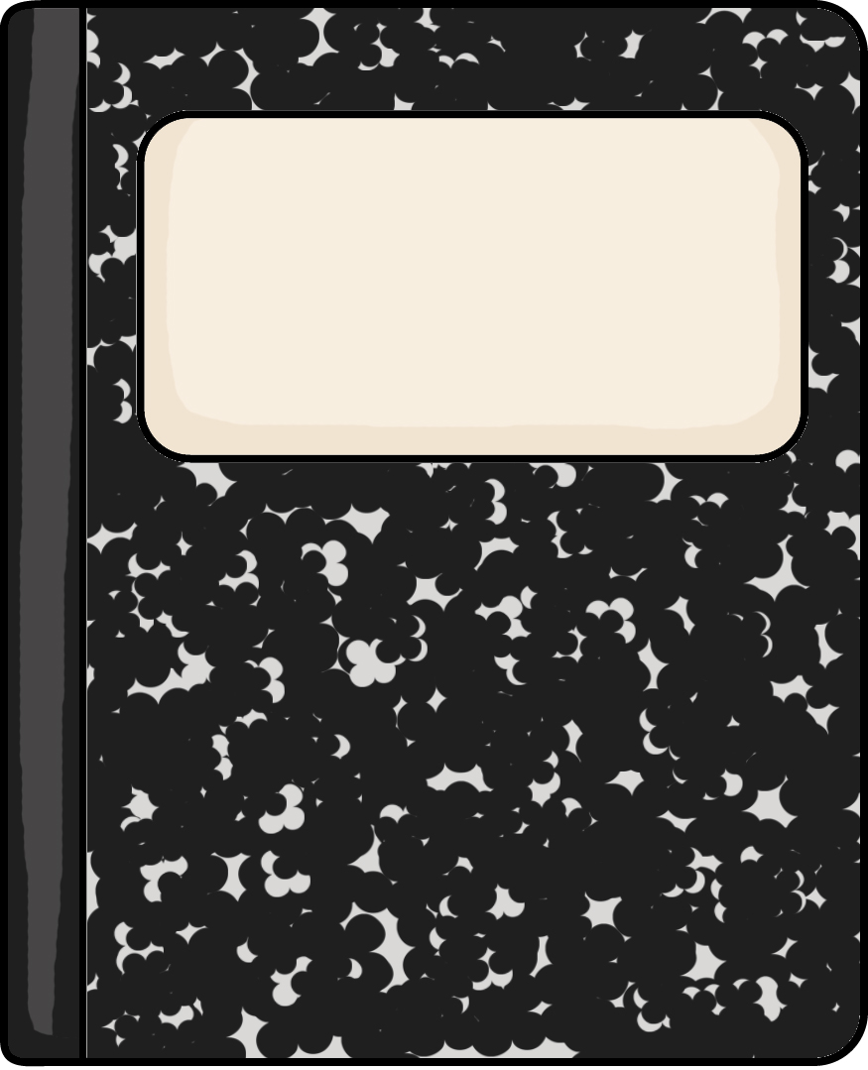

Science

Task Card

Learning Target- Explain what is matter. Describe the properties of an object in the classroom.

Activity:

* Read Lesson 1 with your group.
* Discuss and give examples of matter.
* Choose 3 examples of matter in the classroom and describe 3 different properties of that matter.
* Choose one of the ways below to share your work with your smart device.
  + Draw a picture of your matter and its properties.
  + Write about the matter you chose and list its properties.
  + Take a picture of your matter and tell about its properties.
  + Video-record your group discussing the matter and describing its properties.



Science